Sample Physiology Reports From Wake Forest
Note to Instructors: these reports have been reproduced essentially as they were submitted by the original student authors. We have not corrected misspellings or grammar, nor filled in missing information.

Example Report : Physiology #1

Title
Effect of lanthanum chloride on contraction of gastrocnemius muscle in Rana pipiens

Abstract
In this study we injected lanthanum chloride (LaCl3) to prevent the gastrocnemius muscle from contracting in Rana pipiens. We hypothesized that LaCl3 would stop muscle contraction because LaCl3 blocks calcium channels muscle fibers. The Ca channels are necessary for muscle contraction because they trigger the movement of acetylcholine filled vesicles. These vesicles fuse with the cell wall and release their contents and activate other processes that allow muscles to contract. We used the legs of Rana pipiens to measure contraction after LaCl3 injection. The legs are controled by the gastrocnemius muscle and the sciatic nerve. We exposed the muscle and used pin electrodes to measure the contraction in the legs twice, once before injection and once after. Then we averaged the results of the two tests and ran a 1 tailed paired t-test. This indicated that we found a significant difference in the contraction levels before and after injection.

Introduction
The legs of Rana pipiens are controled by the gastrocnemius muscle and the sciatic nerve. When stimulated with electricity, the leg will twitch and contract. Muscle contraction is due to an action potential that opens calcium ion channels. These Ca ions trigger the movement of acetylcholine filled vesicles to bind with the membrane of the neuron. ACh is released to bind in the synaptic cleft, opening sodium ion channels that depolarize the cell, causing an action potential (Ebashi and Endo: 1968). Lanthanum chloride is a compound that inhibits the opening of calcium channels. This would prevent the vesicle movement and keep ACh from being released into the cleft, preventing the opening of sodium ion channels and thus stopping an action potential from occurring. In this experiment, we plan to inject LaCl3 in the gastrocnemius muscle. We hypothesize that if LaCl3 is injected into the muscle, the contraction will not occur.

Materials and Methods
To perform our experiment we used LaCl3, 3 Rana pipiens legs, a syringe, and software to measure contraction. In order to expose the muscle, we skinned the leg. Once the muscle was exposed we suspended the leg from a ring stand with a force transducer and stuck the electrode pins into the muscle and stimulated at a variety of amplitudes. After we found control results, we injected the LaCl3 into the muscle and waited for it to diffuse evenly. We repeated the measurements for the experimental and then ran a 1 tailed paired t-test to see if our results were significant.

Results
We found that the LaCl3 increased contraction in the first leg and decreased in legs 2 and 3. When injected with LaCl3, leg 1 started contraction at only 0.2v, but legs 2 and 3 did not begin contracting until 1v and 0.4v respectively. The averages of these results are shown in figure 1. Figure 1 shows that in general, contraction went up after LaCl3 was added. The results of our 1 tailed paired t-test were (Degrees of freedom: 8, t-value: 3.95, p-value: 0.00424). The results were significant.

Discussion
We hypothesized that if LaCl3 is injected into the muscle, the contraction will not occur. Although contraction was lowered significantly in legs 2 and 3, results from leg 1 indicated a large increase in contraction. Leg 1 refuted our hypothesis, but legs 2 and 3 supported it. Leg 1 having such a large increase is most likely due to error. When we tested leg 1 we had the pins in the wrong part of the muscle. Other than the main source of error, other error could have occured from different innate muscle contraction ability. It is difficult to compare different legs because they could be of different strengths. This error affected our averages, indicating that contraction increases when LaCl3 is injected, causing our p_value to be under 0.05, but for the wrong reason. When looking at the results from legs 2 and 3, it can be seen that the LaCl3 may have plugged the calcium channels and kept the acetylcholine filled vesicles from binding with the cell membrane. If this occurred, it would prevent muscle contraction because acetylcholine could not be released into the synaptic cleft. However, contraction still occurred in legs 2 and 3, indicating that amplitude could play a role in forcing muscles to contract. It could possibly do this by forcing the voltage gated channels open, and allowing calcium to trigger the vesicles to bind with the membrane. This information can be useful in situation when someone would need to either stop Ca channels or reduce muscle contraction for any reason such as paralyzing someone for medical reasons.

Literature Cited
Ebashi, S., and M. Endo. “Calcium and Muscle Contraction.” Progress in Biophysics and Molecular Biology, vol. 18, 1968, pp. 123–183., doi: 10.1016/0079-6107(68)90023-0.s

Figures
Figure 1
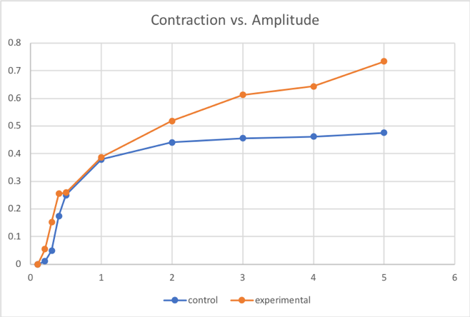

Figure Legends
Figure 1. The experimental group had a higher average contraction at all amplitudes.

Notes For Instructors

Primary Points to Focus On First
- Introduction is a random series of statements with no connecting logical flow. Literature source is simply tacked on.
- The reasoning behind the hypothesis is missing from both the Introduction and Discussion.
- Figure 1 does not have axis titles or any explanation of what is shown. It is impossible to interpret as presented. Also, there are no standard error bars on the data.

Other Points of Concern
- Methods are a list of steps, not a narrative.
- Abstract is fragmented and does not flow from background to experiment to interpretation.
- There are no cited literature sources to support the Discussion.

Example Report: Physiology #2

Title
The Effect of a Calcium Channel Blocker on Muscle Contraction in a Frog Leg

Abstract
Muscle contraction is an intricate process that is dependent upon many different ions to spark action potentials. Manipulating different ion concentrations allows us to better understand the process. In this experiment, we are inserting lanthanum chloride, a calcium channel blocker, into the gastrocnemius muscle of a frog leg to see its effect on threshold amplitude. Because lanthanum chloride is a calcium channel blocker, calcium will have a difficult time being released from the sarcoplasmic reticulum, and action potentials will be scarce. We hypothesized that the lanthanum chloride would produce a higher threshold amplitude. In order to determine the threshold amplitude, we used a computer software program. We calculated the threshold value three separate times for both control and both treatment groups. After gathering all the data from the class, we completed a two sample t-test. It produced a P-value of 0.96. This P-value indicated that the groups are not significantly different.

Introduction
The muscular system of a species’ body is largely dependent upon the neuromuscular system. The contraction, or movement, of the muscles require action potentials. For an action potential to occur, acetylcholine, a neurotransmitter released due to nerve impulses at the neuromuscular junction, must be released from the presynaptic terminal. The binding of acetylcholine to its receptor site on the muscle fiber then causes sodium channels to open and a resulting action potential to occur [Queensland Brain Institute: 2017]. The action potential then travels throughout the muscle, where it reaches the sarcoplasmic reticulum, a calcium storage unit within the muscle, and calcium is released, and the muscle fiber is able to shorten, or contract [Rüegg: 1992].
The ions such as sodium and calcium are extremely important in the function of the neuromuscular system. Calcium ion concentration, in particular, is very important in the contraction of muscles [Excitation Contraction Coupling, http://muscle.ucsd.edu/musintro/ecc.shtml]. In order to understand the effects of their absence in this system, in this experiment we will add lanthanum chloride, a calcium channel blocker, to the gastrocnemius muscle of the frog leg. How will the muscle respond to the addition of this calcium channel blocker? Will the threshold be increased or decreased? We hypothesize that, as the lanthanum chloride is added, the threshold value will be increased. We hypothesize that, because some of the calcium channels will be blocked, calcium will not be able to be released and cause an action potential as quickly as if the calcium channels were open, yielding a higher threshold value in the treatment leg.

Materials and Methods
To test the effect of a calcium channel blocker on the gastrocnemius muscle of a frog, we used syringes to administer the lanthanum chloride. We used a control group to compare the myograms of the treatment groups. Upon collecting the data, a statistical t-test was used to compare the average threshold values between the two groups. We first obtained two frog legs. The dissection procedure was the same for both the control and treatment leg. We labeled one leg as the control and the other as the treatment.
We dissected the frog leg, separating the top portion of the gastrocnemius muscle from the bone. We then attached a piece of thread around the top portion of the muscle and looped it around the hook hanging down from the FT-302 transducer. We made sure there was enough tension in the thread so that the muscle was standing straight up. We cut two small pieces of the silver thread and tied each around the muscle in two different locations, one towards the top and one towards the bottom of the muscle. We then attached the probes to the thread in the two different locations. Using the computer software program, we determined the threshold value by starting at an amplitude value of 0 and increased in small increments. The smallest value at which the muscle contracts was the threshold value. We recorded the threshold three separate times, each time starting at a threshold of 0. Since we only had two frog legs, we performed the control and treatment procedure on both legs. After determining the threshold values with no blocker administered, we added 0.1 ml of lanthanum chloride to the gastrocnemius muscle, inserting the syringe at an angle into two different locations on the muscle, one towards the top and one towards the bottom. We then waited ten minutes before repeating the process of determining the threshold value three times using the computer software system.

Results
The bar graph shows that the control group had a higher threshold amplitude than did the treatment group. These values were determined by averaging the data collected from the two sections combined. To interpret this data, we performed a two sample, one tailed t-test. This gave us a P-value of 0.96.

Discussion
A P-value of 0.96 is much larger than the ideal P-value of 0.05. This large P-value indicates that the groups are not statistically significantly different. This shows that there may have been other factors affecting the threshold amplitude, rather than the presence of a calcium channel blocker. The treatment group has a lower average value of threshold amplitude than the control group, showing the opposite of what we predicted. This causes us to have to reject our alternate hypothesis and accept our null hypothesis, stating that lanthanum chloride did not have a significant effect on threshold.

Literature Cited
- Action Potentials and Synapses. March 26, 2018. https://qbi.uq.edu.au/brain-basics/brain/brain-physiology/action-potentials-and-synapses.
- Rüegg, J.C. 1992. Calcium in Muscle Contraction: Cellular and Molecular Physiology.
- Excitation Contraction Coupling. March 26, 2018. http://muscle.ucsd.edu/musintro/ecc.shtml.

Figures
Figure 1
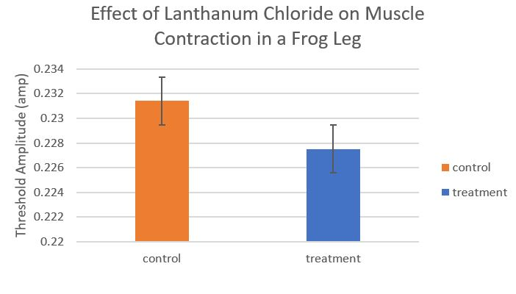

Figure Legends
Figure 1. Bar graph showing the effect of Lanthanum Chloride on muscle contraction in a frog leg.

Notes For Instructors

Primary Points to Focus On First
- The Introduction makes broad over-generalizations about neuromuscular physiology. The system in vertebrates is not the same as the one in invertebrates.
- The reasoning for the hypothesis is flawed. Calcium release is the product of an action potential, not the cause.
- None of the sources cited are allowed types, and there are no primary sources supporting the discussion. Ruegg, 1992 might be acceptable if properly cited, but as written it is impossible to tell where the original source comes from. Web sites may not be used in place of primary literature sources.

Other Points of Concern
- The Abstract is disorganized.
- In the Results, the statistical outcome was not reported correctly.
- The discussion does not talk about any reasons why their original hypothesis was not supported.
- The figure legend is not sufficiently detailed to interpret the results shown.

Example Report: Physiology #3

Title
Effect of Lanthanum Chloride (LaCl3) on Twitch Threshold and Stimulus Amplitude of Rana pipens Gastrocnemius Muscle

Abstract
Previous studies have shown that lanthanum binds to Ca+2 binding site blocking the calcium channel, therefore, preventing proper muscle contractions from occurring. 1 mM of LaCl3 was used on Rana pipens legs to block the calcium channels. Increase in twitch threshold and decrease in stimulus amplitude after the injection of the treatment was observed, but were not significant enough to state that there is a difference in mean twitch threshold and stimulus amplitude before and after the treatment. These observations may be due to the low concentration and insufficient time allowed for the treatment to have its effect on the muscle.

Introduction
Organisms use their nervous system to respond to changes in their environment. Their nervous system has the ability to send signals rapidly, produce specific responses, and send action potentials. Action potentials (APs) are electrical signals generated in the motor neurons of the spinal cord and travel though neuromuscular junctions. When an AP arrives at a neuromuscular junction, depolarization occurs causing the release of acetylcholine (ACh), a neurotransmitter commonly found in muscles, from the presynaptic nerve terminal. ACh diffuses and binds to the receptors on the muscle fiber causing sodium (Na+) channels to open and generate an AP in the muscle fiber. The AP spreads along the muscle fiber causing the release of calcium ions (Ca+2) from the sarcoplasmic reticulum (SR). The release of Ca²⁺ causes the muscle to contract [Johnson: 2016].
Rabbit aortic smooth muscle exposed to 1.5 mM of lanthanum ion (La+3) was found to have La+3 bind to the Ca+2 binding sites instead of Ca+2, therefore preventing the “rebinding and reuptake of Ca+2” and inhibiting proper muscle contractions [Goodman: 1971].
Rana pipiens legs consists of the sciatic nerve and the gastrocnemus muscle. When the sciatic nerve is stimulated or when the gastrocnemus muscle is stimulated, the twitch response of the gastrocnemus muscle is visible, making the Rana pipiens a suitable organism for this experiment.
In our experiment, we examined the effects of lanthanum chloride (LaCl3), a calcium channel blocker [Johnson: 2016], on the muscular response of the Rana pipiens legs. We hypothesize that, if 1 mM of LaCl3 is injected into the Rana pipiens leg, then the twitch amplitude and the stimulus amplitude applied to its nerve will be weaker.

Materials and Methods
For this experiment, three Rana pipiens legs were obtained and maintained on ice. The skin of the Rana pipiens leg was pulled back to reveal the muscles underneath. The sciatic nerve was carefully exposed and separated from the connective tissues of the inner thigh muscles. The gastrocnemus muscle was separated from the tibialis anterior and cut at the Achilles tendon. The Achilles tendon was then tied to a string and suspended to the force transducer (FT302) of the iWorx electrophysiology (EP) recording equipment. The sciatic nerve was placed on the sleeve probe and covered with a rubber sleeve. Ringer’s solution was used throughout the experiment when need to maintain the moisture of the legs.
The iWorx software was used to measure the twitch threshold and the stimulus amplitude. For each of the three legs, the stimulus amplitude was first set to 0.1V and increased in 0.1V increments until a muscle twitch was detected. The stimulus amplitude was then increased or decreased in 0.01V increments until the twitch threshold was determined. The twitch threshold and the stimulus amplitude applied to the nerve was then recorded.
The same three Rana pipiens legs were then injected with 0.2 ml of 1mM LaCl3 into the gastrocnemus muscle and given approximately 10 minutes to spread through the muscle. The same method of measuring the twitch threshold and stimulus amplitude used before the injection was used after the injection.
The results were analyzed using the paired t-test.

Results
There was an increase in the mean twitch threshold after the injection of LaCl3 in the Rana pipiens legs (Figure 1). There was a decrease in the mean stimulus amplitude after the injection of LaCl3 in the Rana pipiens legs (Figure 2). The twitch threshold and stimulus amplitude for all the legs were recorded based on the twitch observed on the gastrocnemus muscle, but twitch was observed in the lower portion of the legs after injection.
There is no significant difference in the mean twitch threshold of the Rana pipiens leg before and after the injection of lanthanum chloride (Figure 1, t-stat = 1.85, d.f. = 2, P = 0.206). There is also no significant difference in the mean stimulus amplitude applied to the nerve of the Rana pipiens leg before and after the injection of lanthanum chloride (Figure 2, t-stat = 0.232, d.f. = 2, P = 0.838).

Discussion
Based on our observations and statistical testing, we reject our hypothesis which stated that, if 1 mM of LaCl3 is injected into the Rana pipiens leg, then the twitch amplitude and the stimulus amplitude applied to its nerve will be weaker, and, instead, support our null hypothesis.
Although LaCl₃ may have the effect of weakening muscle contraction, as seen in a previous experiment with the use of La3+ ion [Goodman: 1971], in our experiment, there was no significant difference in the mean twitch threshold and mean stimulus amplitude applied to the nerve between the control and the treatment. This contrast in results may have been due to the fact that the concentration of LaCl3 was too low or the amount of time for the treatment to be absorbed by the muscle was insufficient for blocking calcium channels. In the experiment performed by Goodman, 1.5 mM of La3+ was used [Goodman: 1971], whereas, in our experiment, 1.0 mM of LaCl₃ was used. Goodman’s use of a higher concentration of La3+, as opposed to our use of a lower concentration of LaCl3 may have contributed to the observation. In a future experiment, we would like to increase the concentration of LaCl3 and also increase the amount of time allowed for the treatment to have its effects on blocking the calcium channels.

Literature Cited
- Johnson AD. Neuromuscular Control. Biological Principles Laboratory Manual. Dept. Biology, Wake Forest University, Winston-Salem, NC. Vers. 16.1 (updated May 1, 2016), pp. 19-35.
- Goodman FR. & Weiss GB. 1971. Effects of lanthanum on 45Ca movements and on contractions induced by norepinephrine, histamine and potassium in vascular smooth muscle. Journal of Pharmacology and Experimental Therapeutics. 177(2): 415-425.

Figures
Figure 1
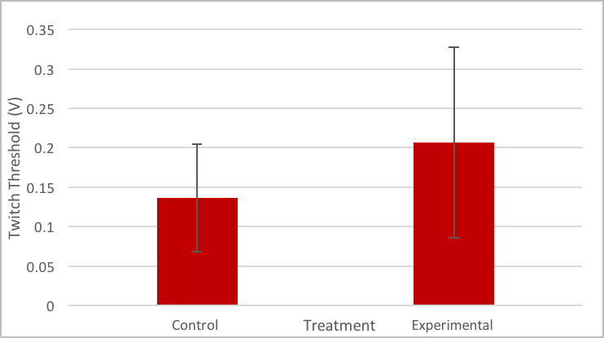
Figure 2
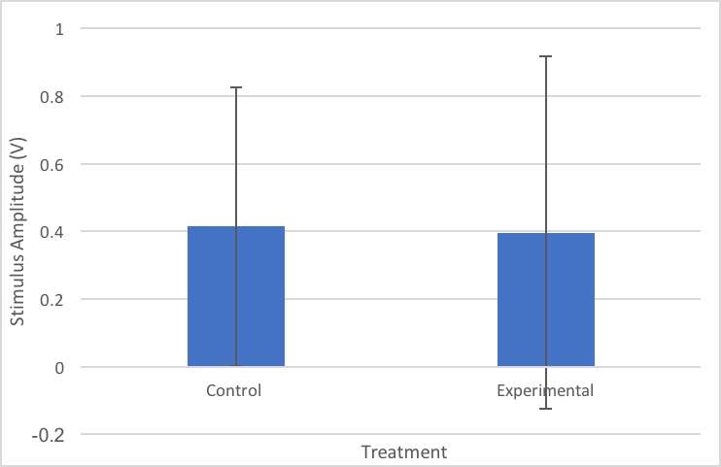

Figure Legends
Figure 1: The twitch threshold measured in volts of three Rana pipiens legs, with lanthanum chloride treatment (experimental) and without (control). The error bars represent the standard deviation. The bars represent the twitch threshold. The difference in mean between the control (n=3) and experimental (n=3) was not significant (paired t-test: t-stat=1.85, d.f.=2, P=0.206).
Figure 2: The stimulus amplitude measured in volts of three Rana pipiens legs, with lanthanum chloride treatment (experimental) and without (control). The error bars represent the standard deviation. The bars represent the stimulus amplitude. The difference in mean between the control (n=3) and experimental (n=3) was not significant (paired t-test: t-stat=0.232, d.f.=2, P=0.838).

Notes For Instructors
This particular report is a good example of how a report can be good overall, yet still have points where it could be improved.

Primary Points to Focus On First
- This report does a good job integrating prior observations from [Goodman: 1971]. A more recent source would have been better.
- Both the Results section and the figure legends have reported the statistical results correctly.
- The report would benefit from additional primary sources to support an explanation or argument why their original hypothesis did not match their observations.

Other Points of Concern
- The Introduction makes broad over-generalizations about neuromuscular physiology. The system in vertebrates is not the same as the one in invertebrates.
- Methods section could be condensed and streamlined.

